1.Explain one disadvantage of the area of the upper course of a river for human activity?
_______________________________________________________________________________________________________________________________________________________________________________________________________________________________________________________________ (2marks)
2.describe two types of deltas? ____________________________________________________________________________________________________________________________________________________________________________________________________________________________________________________________________________________________________________________________________________________(4 Marks)
b. Explain two problems of living in delta areas?
____________________________________________________________________________________________________________________________________________________________________________________________________________________________________________________________________________________________________________________________________________________(4 Marks)

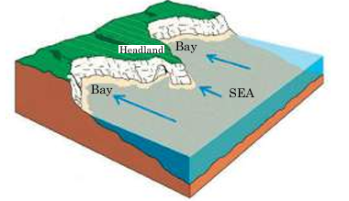
s

i.name the feature labelled S
____________________________________________( 1 mark)
ii. Explain how a headland is formed
______________________________________________________________________________________________________________________________________________________________________________________________________________________________________________________________________________________________________________________________________________________________________________________________(5 marks)
iii. outline two reasons why coastal landforms are important
___________________________________________________________________________________________________________________________________________________________________________________________________________________________________________________________________________________________________________________________________________(4 marks)
3. One of your classmates has brought some rock samples to school. You
have been asked to identify the sedimentary rock. List two of the
characteristics you would look for.
____________________________________________________________________________________________________________________________________________________________________________________________________________________________________________________________________________________________________________________________________________________(4 MARKS)
4.What features are associated with waterfalls? Name any two
_______________________________________________________________________________________________________________________________________________________________________________________________________________________________________________________ (2 marks)
5.What is the difference between basic lava and acid lava? Give two
points.
_______________________________________________________________________________________________________________________________________________________________________________________________________________________________________________________________________________________________________________________________________________(4 marks)
6.Below is the diagram of a rock circle use it to answer the questions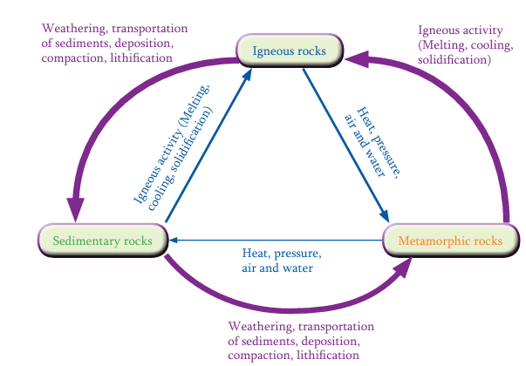
G
S
Q
Z
i. List the processes labelled (3 marks)
S_____________________________________________________
Z______________________________________________________
G______________________________________________________
ii. Explain how Q rocks are formed
____________________________________________________________________________________________________________________________________________________________________________________________________________________________________________________________________________________________________________________________________________________(5 marks)
iii. explain two reasons why rocks Q are important
________________________________________________________________________________________________________________________________________________________________________________________________________________________________________________________________________________________________________________________________________________________________________________________________________________________________(4 marks)
iv. Explain how sedimentary rocks change to metamorphic rocks
________________________________________________________________________________________________________________________________________________________________________________________________________________________________________________________________________________________________________________________(3 marks)
iii. Give two examples of igneous rocks (2 marks)
a_______________________________________
b_________________________________________
7.a. With examples, explain any two ways in which shield areas are economically important
____________________________________________________________________________________________________________________________________________________________________________________________________________________________________________________________________________________________________________________________________________________(4 marks)
b. why is an earthquake’s destructiveness more extensive at the epicenter than away from it?
_________________________________________________________________________________________________________________________________________________________________________________________________________________________________________________________ (2 marks)
8.Study The diagram below and answer the questions that follows.
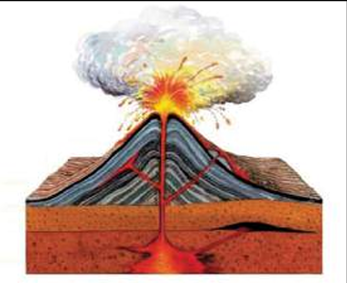
Z
T

S
Q

i.name the parts labelled (3 marks)
Z___________________________________
T____________________________________
Q_____________________________________
ii. Explain why part Z is important
__________________________________________________________________________________________________________________________________________________________________________ (2 marks)
iii. Explain the formation of a volcano
____________________________________________________________________________________________________________________________________________________________________________________________________________________________________________________________________________________________________________________________________________________(5 marks)
c. Explain why igneous rocks do not contain fossils?
__________________________________________________________________________________________________________________________________________________________________________ (2 marks)

9.Explain the three stages of a volcano’s life cycle?
______________________________________________________________________________________________________________________________________________________________________________________________________________________________________________________________________________________________________________________________________________________________________________________________________________________________________________________________________________________________________________________________(6 marks)
10.a. List any three major ocean currents that are found in the world?
____________________________________________________________________________________________________________________________________________________________________________________________________________________________________________________ (3 marks)
c. Explains two causes of ocean currents?
____________________________________________________________________________________________________________________________________________________________________________________________________________________________________________________________________________________________________________________________________________________(4 marks)
c. Describe two reasons why ocean currents are important?
____________________________________________________________________________________________________________________________________________________________________________________________________________________________________________________________________________________________________________________________________________________(4 marks)
11.why are some ocean currents warm while others ae cold?
__________________________________________________________________________________________________________________________________________________________________________ (2 marks)
12.Distinguish between the continental shelf and continental rise
_____________________________________________________________________________________________________________________________________________________________________________________________________________________________ (4 marks)
13.a. With the aid of a diagram, describe shearing or sliding plate movement (5 marks)

b. Explain three types of tectonic plate boundaries
___________________________________________________________________________________________________________________________________________________________________________________________________________________________________________________________________________________________________________________________________________________________________________________________________________________________________________________________________________________________________________________________________________________________(6 mark
End of question paper

